

Capstone Project Report
Report 3 – Software Requirement Specification

– Hochiminh, August 2026 –
Table of Contents
I. Record of Changes 3
II. Software Requirement Specification 4
1. Overall Description 4
1.1 Product Overview 4
1.2 Business Rules (BR) 4
2. User Requirements 5
2.1 Actors 5
2.2 Use Cases 7
3. Functional Requirements 8
3.1 System Functional Overview 8
3.2 FE-01: Multi-modal Ingestion (Text, Image) 21
3.3 FE-02: Automated Parsing & Unit Check 22
3.4 FE-03: Physics Law Invariant Verification & Cross-Validation 24
3.6 FE-05: Interactive Live Classroom Player 25
3.7 FE-06: Portable Simulation Exporting 26
3.8 FE-07: Teacher Library & Assignment Management 27
3.9 FE-08: Student Prediction & Replay Sandbox 28
3.10 FE-09: Content Curation & Schema Workspace 30
3.11 FE-10: System Administration (Users & Topics) 31
4. Non-Functional Requirements 32
4.1 External Interfaces 32
4.2 Quality Attributes 34
5. Requirement Appendix 36
5.1 Business Rules 36
5.2 Common Requirements 37
5.3 Application Messages List 38
5.4 Other Requirements, Acronyms & Glossary 43

I. Record of Changes
Date | A*  M, D | In charge | Change Description
15/09/2026 | A | VietNHB | Drafted initial SRS structure, core actors, and baseline use case list.
24/09/2026 | M | HungNT | Added System Context Diagram, Dual-Solver tolerance rules, and B2B School Licensing logic.
06/10/2026 | M | HungNT | Refined 7-Actor Role-Based Access Control (RBAC) matrix and 3-Pane Studio workflows.
18/10/2026 | M | HungNT | Integrated Anti-Cheat parameter seeding (PRNG), account dispute governance (SUSPENDED_READ_ONLY), and Flyway V50 schema constraints.
23/10/2026 | M | All Members | Finalized Phase 1 SRS: Completed System Overview, Business Rules (BR-01 to BR-08), 7 Actors, and Use Case Catalog.
28/10/2026 | M | HungNT | Refined Functional Requirements (FE-03, BR-01): Replaced legacy 2% discrepancy gate with Domain Physics Law Verification & Self-Repair Loop per Supervisor review.
*A - Added M - Modified D - Deleted

II. Software Requirement Specification

1. Overall Description

1.1 Product Overview
PhysLive is a web-based, AI-augmented educational SaaS platform designed to modernize high-school physics education (aligned with the Vietnamese GDPT 2018 curriculum). The platform bridges the gap between abstract mathematical textbook problems and intuitive empirical observation by automatically ingesting natural-language physics statements (via typed text or OCR image uploads), validating their mathematical and physical consistency through a Physics Law Invariant Verification Engine (analytical/numerical Runge-Kutta solver cross-checked against a visual 2D Pixi.js v8 canvas engine), and rendering interactive, real-time kinetic simulations.
The system serves both B2B institutional clients (high schools, tutoring centers subscribing to annual pooled simulation tokens) and B2C users (independent educators and students).
System Context Diagram
The Context Diagram below illustrates the boundary of the PhysLive platform and its external interacting entities:
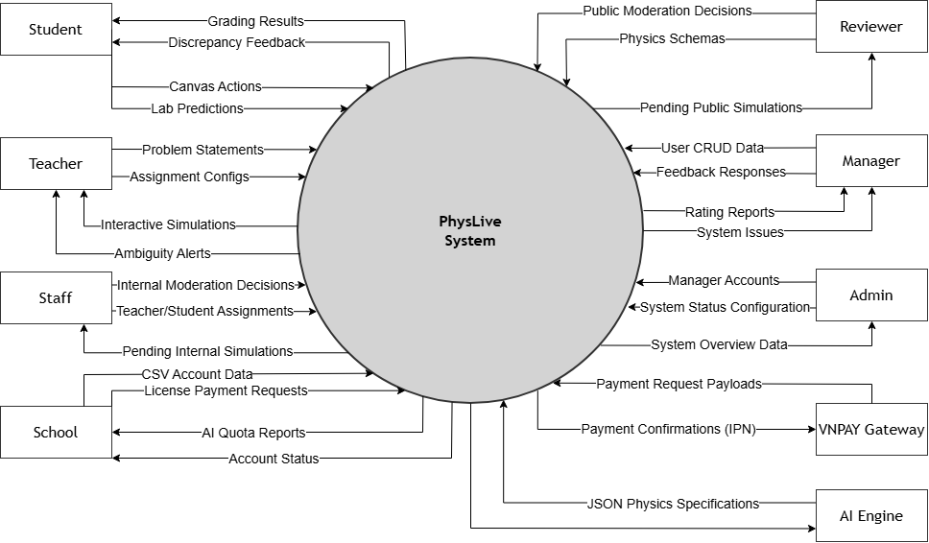
Figure 1. Context Diagram

1.2 Business Rules (BR)
- BR-01: Physics Law Invariant Compliance Gate:
Every simulation generated by the AI parser must be evaluated simultaneously by both the Analytical/Numerical Solver (closed-form Runge-Kutta ODE) and the Visual Kinetic Engine (Pixi.js v8).
The simulation is certified as READY (VERIFIED) only when the numerical Runge-Kutta 4th order (RK4) time series strictly satisfies the domain physical invariant laws (Conservation of Mechanical Energy, Newton's 2nd Law, Conservation of Momentum, Ohm's Law) defined in the GDPT 2018 Law Catalogue. If any core invariant is violated or numerical divergence is detected, the run is tagged as FLAGGED and routed through an automated LLM self-repair loop to eliminate hallucinations.
- BR-02: B2B Institutional Token Quota Governance:
Schools subscribe to annual plans (BASIC, STANDARD, PREMIUM). Each plan provides a fixed monthly pool of AI extraction tokens (e.g., 50,000 tokens/month).
Every AI OCR problem parsing or LLM extraction deducts tokens from the school's active monthly quota. If the quota reaches zero, teachers and students are restricted to using pre-existing library simulations until the next billing cycle or an add-on top-up is purchased.
- BR-03: Multi-Tenant Role Isolation:
Platform roles (ADMIN, MANAGER, REVIEWER) must have school_id = NULL.
Institutional roles (SCHOOL, STAFF, STUDENT) must have a valid school_id. Data access is strictly compartmentalized: teachers and students can only view classes, assignments, and rosters belonging to their registered school.
- BR-04: Three-Tier Account Suspension & Appeal Governance:
Users are governed by three account states: ACTIVE, WARNED, and SUSPENDED_READ_ONLY.
Users in SUSPENDED_READ_ONLY status are prohibited from all mutation operations (creating simulations, posting comments, submitting assignments). However, they retain view-only access (SELECT) and are permitted to submit an official dispute petition to the account_appeals registry for Manager adjudication.
- BR-05: Randomized Parameterization for Anti-Cheating:
When assigning homework to a class, teachers can define parameter variance templates
The system utilizes a seeded Pseudo-Random Number Generator (PRNG) combining student_id and assignment_id to generate deterministic, unique problem instances for each student, ensuring fairness while completely preventing answer copying.
- BR-06: Human-in-the-Loop Ambiguity Resolution:
If a problem statement lacks critical boundary, the AI parser flags the specification as NEEDS_CONFIRMATION and provides interactive clarification chips. The teacher or student must resolve the ambiguity before simulation compilation proceeds.
- BR-07: Community Library Moderation Workflow:
Simulations submitted to the public community repository enter a PENDING state. Only accredited REVIEWER accounts can inspect, approve (APPROVED), feature (FEATURED), or reject (REJECTED with a detailed rationale) public visibility.
- BR-08: Three-State Payment Lifecycle:
Institutional subscription transactions strictly transition through: PENDING -> PAID or FAILED. School accounts and token quotas are provisioned or renewed only upon receiving verified Instant Payment Notification (IPN) webhooks.

2. User Requirements

2.1 Actors
# | Actor | Description
1 | Guest | Unauthenticated public visitor. Can browse the public simulation showcase, inspect subscription pricing tiers, and initiate School registration.
2 | Student | High-school learner. Enrolls in classes, executes interactive simulations, submits scientific predictions (POE workflow), completes randomized assignments, and reviews feedback.
3 | Staff | Physics Teacher. Ingests problem statements (text/images), customizes simulation parameters, creates structured homework, assigns tasks to classes, and grades student submissions.
4 | School | High School Institutional Account. Manages academic classes, imports teacher/student rosters via CSV, monitors monthly token balances, and handles subscription billing.
5 | Manager | Platform Operational Manager. Oversees B2B institutional contracts, approves subscription payments, allocates token quotas, moderates curriculum taxonomies, and resolves account suspension appeals.
6 | Reviewer | STEM Pedagogical Specialist. Audits community simulation submissions, curates gold-standard benchmark datasets, tests numerical accuracy, and logs physics formula gaps.
7 | Admin | Root Platform Administrator. Manages platform Manager credentials, monitors overarching system health, and conducts top-level audit logging.

2.2 Use Cases

2.2.1 Diagram(s)
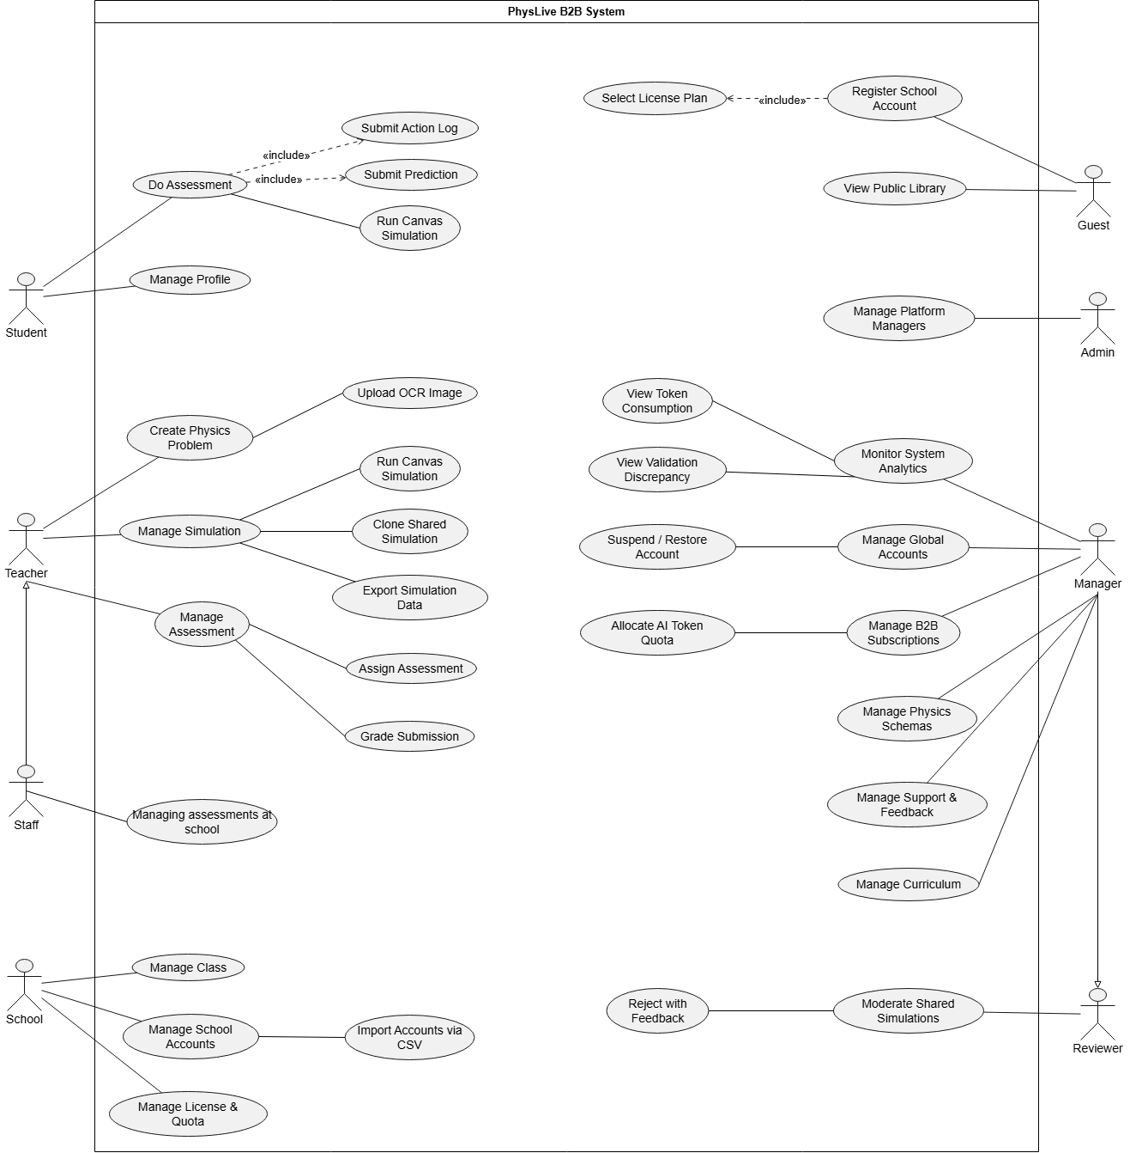
Figure 2. Use case diagram

2.2.2 Descriptions
ID | Use Case | Actors | Use Case Description
UC-01 | Register School Account | Guest | Registers an institutional account with school credentials and selects an annual license plan.
UC-02 | View Public Library | Guest / Student | Explores public community physics simulations with pre-validated kinetic animations.
UC-03 | Input Problem Statement | Staff | Enters raw physics problem text or uploads textbook photos for automated AI OCR parsing.
UC-04 | Resolve Ambiguity | Staff / Student | Resolves missing physical parameters using interactive prompt chips before compiling the simulation.
UC-05 | Run Interactive Simulation | Staff / Student | Plays, pauses, steps, and manipulates real-time 2D Canvas physics simulations with dynamic vector HUDs.
UC-06 | Export Simulation Artifact | Staff | Exports simulation states, parameter cards, or standalone HTML/PDF lab worksheets.
UC-07 | Assemble & Assign Homework | Staff | Bundles problem simulations with questions and randomized anti-cheat parameters for class distribution.
UC-08 | Submit Prediction (POE) Student | Student | Submits qualitative or quantitative predictions before simulation execution as part of the learning workflow.
UC-09 | Complete & Submit Homework | Student | Solves assigned problems, enters numeric metrics, and submits work for automated AI/manual teacher grading.
UC-10 | Grade Submissions | Staff | Reviews auto-graded student scores, adjusts rubric points, and provides contextual feedback.
UC-11 | Manage Classes & Rosters | School | Creates academic classrooms, assigns grade levels, and links assigned teachers.
UC-12 | Batch Import Accounts | School | Ingests bulk teacher and student accounts via structured CSV spreadsheets.
UC-13 | Manage School Subscription | School | Monitors remaining monthly AI simulation tokens, reviews renewal dates, and upgrades license plans.
UC-14 | Moderate Community Content | Reviewer | Evaluates community submissions, approves public distribution, or rejects with educational feedback.
UC-15 | Audit Physics Schemas & Gaps | Reviewer | Benchmarks physics models against gold-standard solutions and logs formula discrepancies.
UC-16 | Oversee B2B Contracts | Manager | Verifies bank transfer receipts, activates school subscriptions, and configures custom token allocations.
UC-17 | Account Dispute & Appeal | Manager | Reviews suspension appeals submitted by penalized users and decides whether to reinstate or reject.
UC-18 | Manage Curriculum Structure | Manager | Edits and standardizes the hierarchical curriculum taxonomy (Topic -> Module -> Grade -> Lesson).
UC-19 | System Administration | Admin | root administrator and platform manager accounts, overseeing system health metrics.

3. Functional Requirements

3.1 System Functional Overview
The PhysLive platform delivers an integrated simulation-first educational environment supported by automated multimodal problem comprehension, rigorous Physics Law Invariant Gate validation, multi-tenant B2B institution administration, anti-cheat assessment pipelines, and community content governance. This section outlines the overarching functional architecture through screen flows, view catalog, role-based authorization matrix, automated non-screen backend services, and the core entity relationship model.

3.1.1 Screens Flow
The platform's user navigation and stateful transitions are organized around three primary end-to-end operational flows:
Flow 1: Problem Ingestion to Interactive Simulation Flow
This flow governs how teachers (`STAFF`) transform raw textbook problems into interactive 2D physics simulations via AI extraction, ambiguity clarification, and Physics Law Invariant Gate verification.
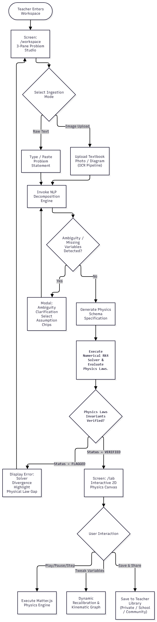
Figure 3. Problem Ingestion to Interactive Simulation Flow
Flow 2: B2B School Subscription, Licensing & Token Allocation Flow
This flow models the institutional onboarding, plan selection, payment settlement, and automated AI simulation token quota provisioning.
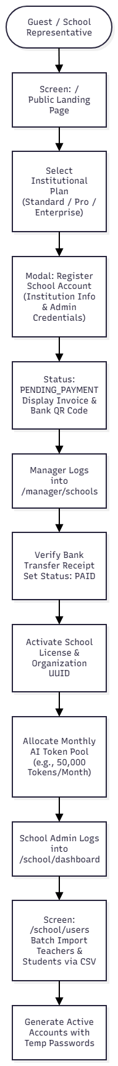
Figure 4. B2B School Subscription, Licensing & Token Allocation Flow
Flow 3: Assessment, Assignment & Anti-Cheat Grading Flow
This flow details how teachers assemble randomized problem assignments, how students submit predictions before running simulations, and how automated grading executes.
Figure 5. Assessment, Assignment & Anti-Cheat Grading Flow

3.1.2 Screen Descriptions
# | Feature | Screen | Description
1 | Landing & Promotion | / (Home View) | Public portal highlighting platform features, interactive sandbox teaser, pricing tiers, and institutional registration entrance.
2 | Public Exploration | /community (National Library) | Searchable repository of peer-reviewed, published physics simulations categorized by curriculum grade level and topic.
3 | Multimodal Studio | /workspace (Problem Studio) | 3-Pane workspace comprising raw text/OCR input pane, extracted schema entity tree pane, and diagnostic validation preview.
4 | Simulation Lab | /lab (Interactive 2D Lab) | Full-screen interactive HTML5 Canvas featuring Pixi.js v8 2D WebGL/WebGPU graphics engine, playback toolbar, vector overlay toggles, and live plotting graphs.
5 | Homework Builder | /teacher/assignments | Class assignment console allowing teachers to assemble homework sets, configure anti-cheat parameter ranges, and set submission deadlines.
6 | Teacher Gradebook | /teacher/grading/:id | Grading workstation displaying student hypothesis vs simulation discrepancies, automated score breakdowns, and rubric adjustment controls.
7 | Student Dashboard | /student (Student Home) | Overview dashboard showing upcoming assignment deadlines, class announcements, recent simulation lab history, and performance metrics.
8 | Student Tasks | /student/assignments | Filterable list of assigned, in-progress, and graded physics problem sets with due dates and completion badges.
9 | Assessment Player | /student/assignments/:id | Dedicated 3-stage POE (Predict-Observe-Explain) player that enforces prediction lock-in prior to interactive canvas simulation execution.
10 | Institutional KPI | /school/dashboard | Administrative overview tracking enrolled student count, active teacher rosters, monthly AI token consumption, and license validity days.
11 | Academic Rosters | /school/classes | Academic structure manager for creating grade sections, assigning homeroom teachers, and auditing class student enrollments.
12 | User Provisioning | /school/users | School-level account management view supporting single account creation and bulk CSV roster importation with automated error reporting.
13 | License & Billing | /school/billing | Subscription management screen displaying active plan tier, remaining token balance, payment history, and renewal upgrade invoices.
14 | Manager Overview | /manager/overview | Cross-school operational dashboard displaying multi-tenant token consumption graphs, system-wide active users, and payment revenue timelines.
15 | B2B Subscriptions | /manager/schools | Tenant administration console for approving new school registrations, auditing institutional accounts, and managing suspension penalties.
16 | Plans & Quotas | /manager/plans | Configuration console for defining institutional license tiers, token pool capacities, and annual pricing rates.
17 | Curriculum Taxonomy | /manager/curriculum | Hierarchical curriculum editor managing the standardized Vietnamese GDPT 2018 taxonomy (Topics, Content Modules, Grade Levels, and Lessons).
18 | Peer Review Console | /reviewer/moderation | Moderation workspace for inspecting community simulation submissions, verifying physics correctness, approving publications, or logging revision notes.

3.1.3 Screen Authorization
The table below defines granular access permissions across all 18 platform views for the 7 defined system roles:
Screen Route | GUEST | STUDENT | STAFF | SCHOOL | ADMIN | MANAGER | REVIEWER
/ (Public Landing) | ✓ | ✓ | ✓ | ✓ | ✓ | ✓ | ✓
/community (Public Library) | ✓ | ✓ | ✓ | ✓ | ✓ | ✓ | ✓
/workspace (Problem Studio) | - | - | ✓ | - | - | - | ✓
/lab (2D Physics Canvas) | - | - | ✓ | - | - | - | ✓
/teacher/assignments | - | - | ✓ | - | - | - | -
/teacher/grading/:id | - | - | ✓ | - | - | - | -
/student (Dashboard) | - | ✓ | - | - | - | - | -
/student/assignments | - | ✓ | - | - | - | - | -
/student/assignments/:id | - | ✓ | - | - | - | - | -
/school/dashboard | - | - | - | ✓ | - | - | -
/school/classes | - | - | - | ✓ | - | - | -
/school/users (CSV Import) | - | - | - | ✓ | - | - | -
/school/billing | - | - | - | ✓ | - | - | -
/manager/overview | - | - | - | - | - | ✓ | -
/manager/schools | - | - | - | - | - | ✓ | -
/manager/plans | - | - | - | - | - | ✓ | -
/manager/curriculum | - | - | - | - | - | ✓ | -
/reviewer/moderation | - | - | - | - | - | - | ✓
/admin (System Audit - View Only) | - | - | - | - | ✓ | - | -
/admin/users (Role Audit - View Only) | - | - | - | - | ✓ | - | -

*Note: In compliance with strict multi-tenant isolation, `SCHOOL`, `STAFF`, and `STUDENT` accounts are constrained by PostgreSQL Row-Level Security (RLS) to access only data linked to their specific `school_id`.*

3.1.4 Non-Screen Functions
The platform relies on six background services, asynchronous workers, and automated scheduled routines to ensure computation integrity, data synchronization, and security enforcement:
# | Feature Reference | System Function | Execution Trigger | Description
NS-01 | FE-01 Problem Ingestion | Multimodal Vision OCR Worker | Async API Request on image drop | Receives cropped image uploads, pre-processes image contrast, invokes cloud vision extraction (OpenRouter / PaddleOCR), and normalizes Vietnamese text with LaTeX inline math symbols.
NS-02 | FE-02 Schema Parsing | NLP Decomposition & Unit Normalizer | Asynchronous Pipeline Service | Breaks natural-language physics problem text into structured JSON entities, quantities, initial conditions, and target unknowns, converting all units to standard SI (m, s, kg, N, J).
NS-03 | FE-03 Law Validation | Physics Law Invariant Verification | Synchronous Worker upon Schema generation | Executes Runge-Kutta 4th Order (RK4) numerical integration and cross-checks state variables against the Physics Law Catalogue; assigns verification status (VERIFIED, PARTLY_VERIFIED, FLAGGED) and triggers self-repair loop on violation.
NS-04 | FE-06 / FE-07 Anti-Cheat | PRNG Deterministic Seeded Generator | Server-side during Assignment creation & fetch | Generates student-specific randomized variable values using deterministic pseudo-random hashing based on student UUID and assignment ID, computing individual expected ground truths.
NS-05 | FE-09 Quota & Billing | Token Ledger & Quota Renewal Scheduler | Scheduled Cron Job (Daily 00:00 UTC) | Aggregates daily token usage across all tenant schools, checks against active license quotas, and automatically resets monthly token allowances on plan anniversary dates.
NS-06 | FE-10 Administration | Account Status & Appeal Lifecycle Worker | Scheduled Cron Job (Hourly) | Scans user accounts flagged as SUSPENDED_READ_ONLY, checks appeal review timestamps, archives resolved disputes, and terminates expired trial school licenses.

3.1.5 Entity Relationship Diagram
The database architecture is implemented on PostgreSQL (Supabase) and managed through Flyway schema migrations. The core schema comprises 20 fully connected relational tables:
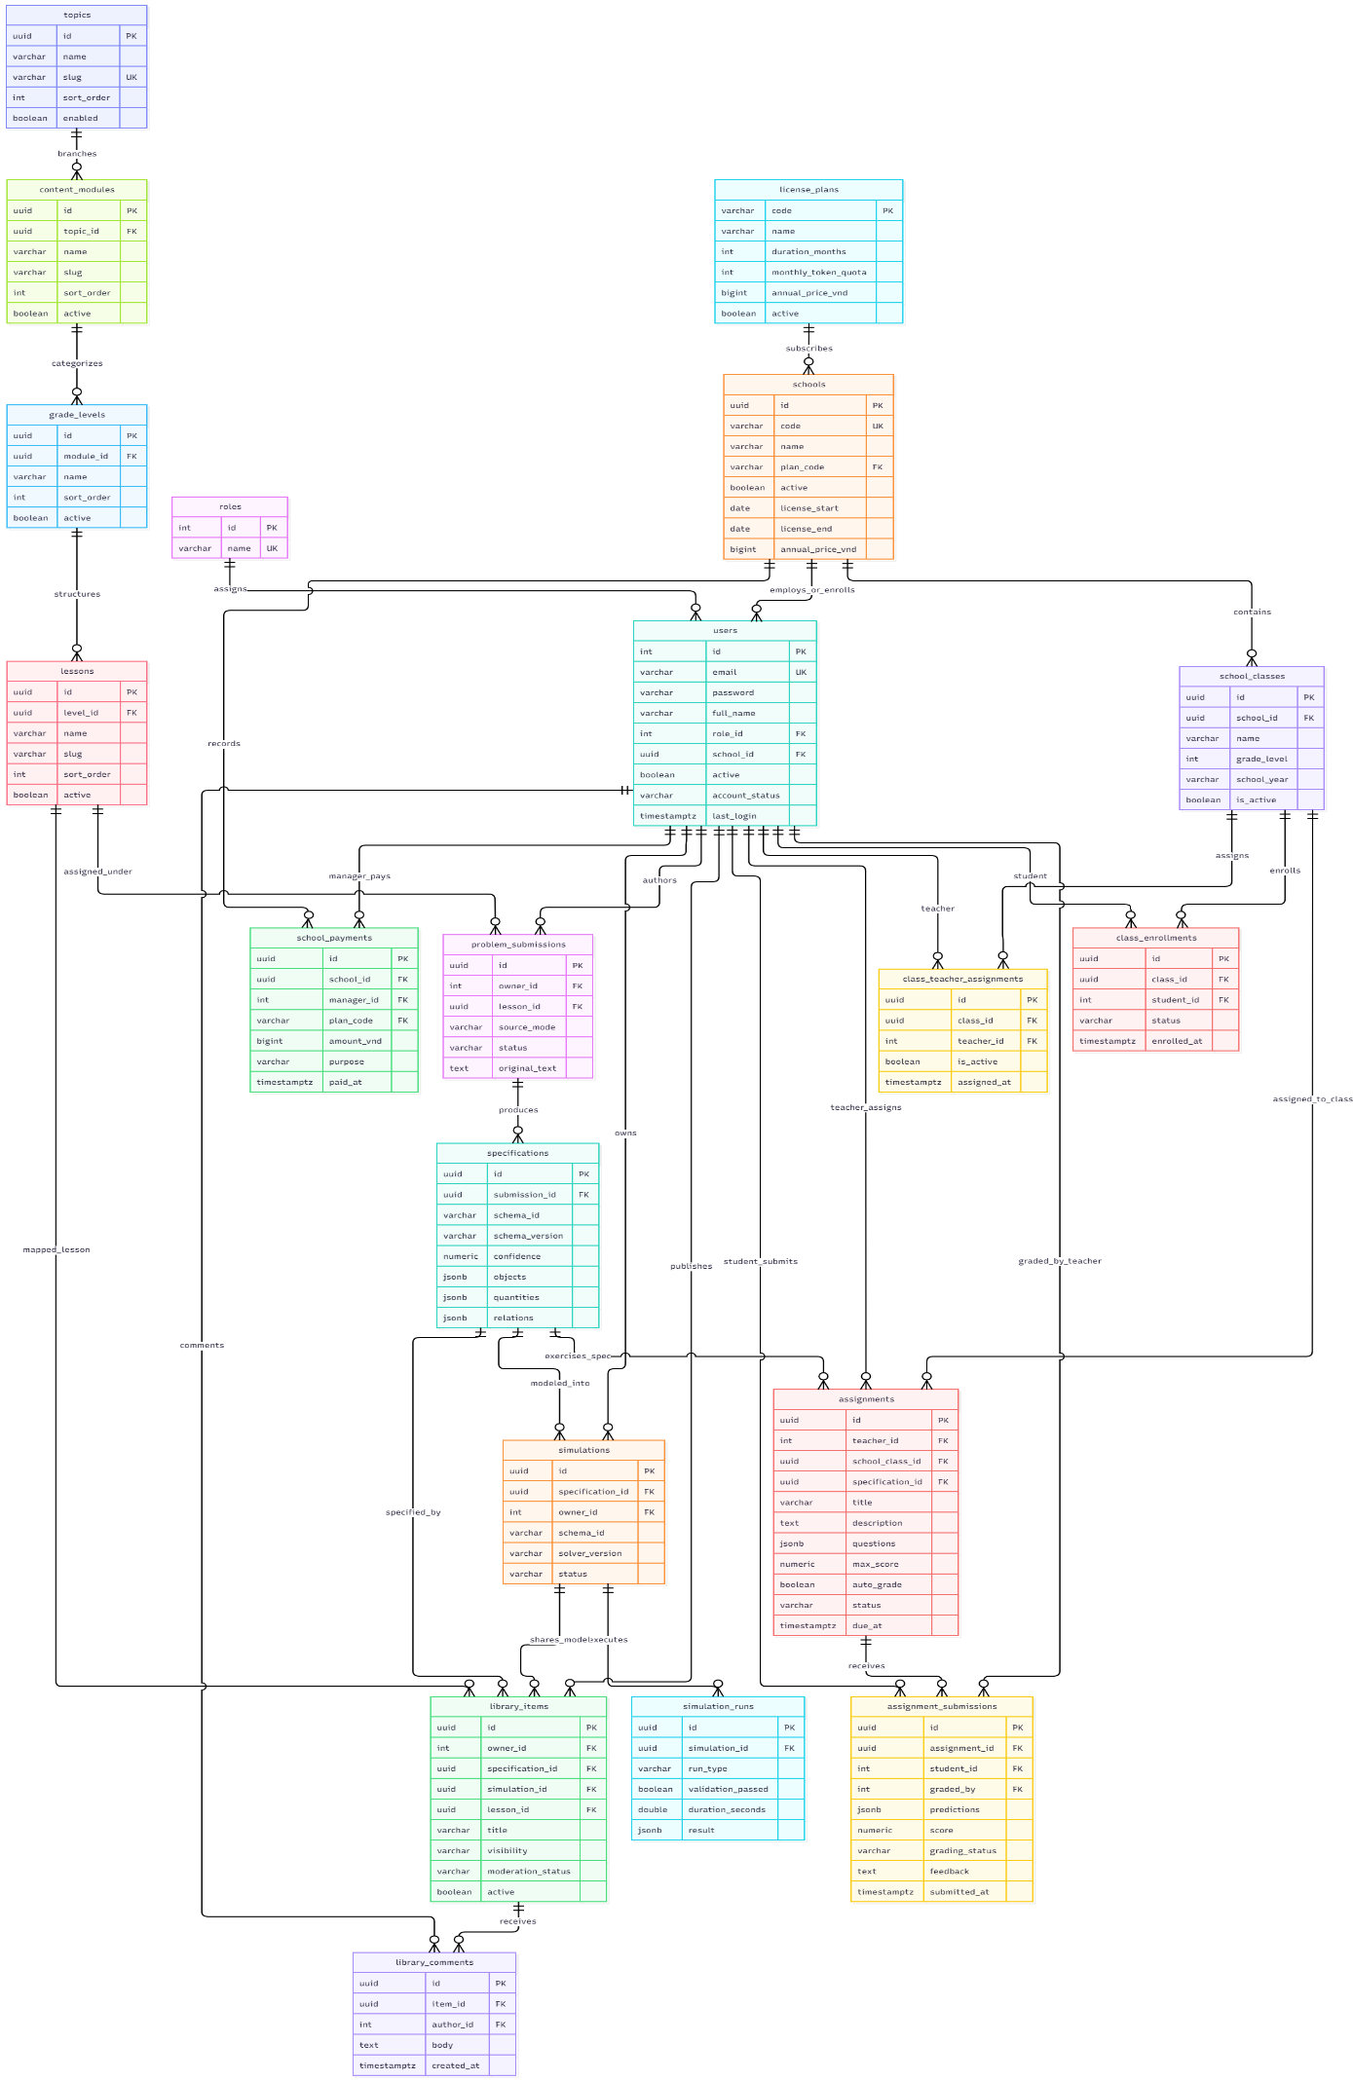
Figure 6. Entity Relationship Diagram (ERD)
Entities Description
# | Entity Name | Database Table | Description
1 | Role | roles | System authorization roles catalog ( GUEST , STUDENT , STAFF , SCHOOL , ADMIN , MANAGER , REVIEWER ).
2 | User | users | Core user identity records storing hashed credentials, assigned role, tenant school association, and account status ( ACTIVE , WARNED , SUSPENDED_READ_ONLY ).
3 | School | schools | Multi-tenant educational institutions subscribing to PhysLive, holding licensing validity dates and unique tenant codes.
4 | License Plan | license_plans | Standardized B2B subscription tiers (Standard, Pro, Enterprise) defining monthly AI token allowances and pricing rates.
5 | School Payment | school_payments | Audited financial transaction records of school subscription payments verified by platform managers ( PAID , PENDING , FAILED ).
6 | School Class | school_classes | Academic classroom sections within a school categorized by grade level (10, 11, 12) and academic school year.
7 | Class Enrollment | class_enrollments | Many-to-many relationship mapping students to their enrolled school classes.
8 | Teacher Assignment | class_teacher_assignments | Mapping linking academic classes to authorized subject teachers.
9 | Topic | topics | Top-level curriculum domain nodes (e.g., Mechanics, Thermodynamics, Electromagnetism).
10 | Content Module | content_modules | Sub-domains under curriculum topics (e.g., Kinematics, Dynamics, Rotational Motion).
11 | Grade Level | grade_levels | Curriculum grouping categorized by secondary education grade standards (Grade 10, Grade 11, Grade 12).
12 | Lesson | lessons | Granular pedagogical units (e.g., "Projectile Motion on Incline") mapped to standardized hierarchical codes (e.g., K01-10-01 ).
13 | Problem Submission | problem_submissions | Raw input problem records submitted by teachers via direct text entry or OCR image scanning.
14 | Specification | specifications | Structured JSON physics schemas produced by NLP parsing, containing extracted physical bodies, quantities, coordinates, and boundary constraints.
15 | Simulation | simulations | Executable simulation model configurations compiled from validated physics specifications.
16 | Simulation Run | simulation_runs | Individual run execution records capturing solver discrepancies, run duration, and frame logs.
17 | Library Item | library_items | Published or shared simulation resources cataloged under private, school-wide, or public community visibility.
18 | Library Comment | library_comments | Discussion threads and peer feedback posted by educators and students on library simulation models.
19 | Assignment | assignments | Structured homework sets assembled by teachers, containing seeded parameter configurations and due dates.
20 | Assignment Submission | assignment_submissions | Student homework responses containing student-specific parameter values, initial predictions, and calculated scores.

3.2 FE-01: Multi-modal Ingestion (Text, Image)

3.2.1 Text & Image Ingestion Studio
- Function Trigger: Staff navigates to /workspace and clicks "New Problem", or drags an image file into the dropzone.
- Function Description: Allows educators to input physics problem descriptions either by typing/pasting raw text (Vietnamese or English) or by uploading textbook photos, diagrams, or scanned exam problems. The system invokes an OCR pipeline to extract textual content and mathematical formulas into a clean digital representation.
- Screen Layout :
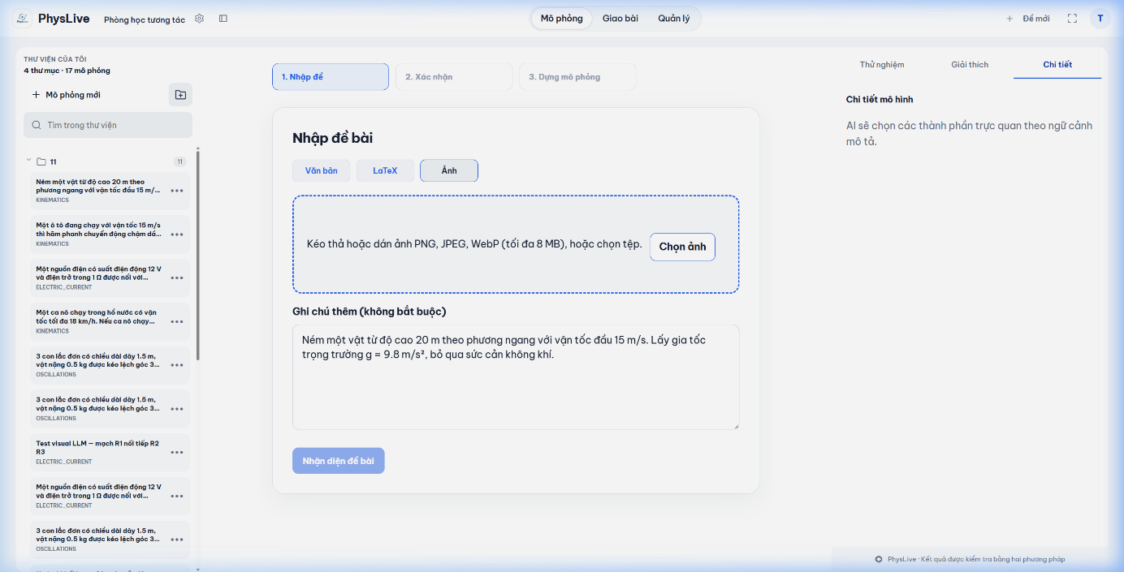
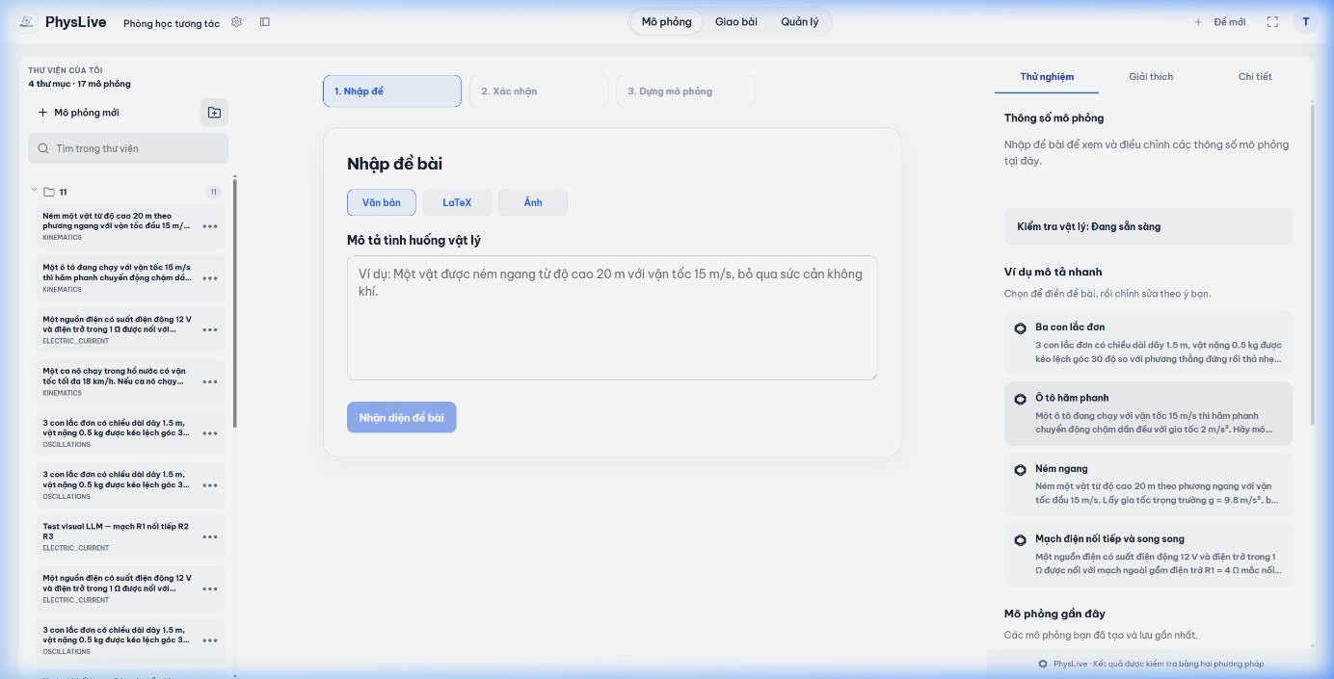
Figure 7. Text Ingestion & OCR Image Upload UI
Function Details:
- Normal Case:
- User enters raw text or uploads a JPEG/PNG image up to 10 MB.
- System verifies user's school AI token quota balance.
- If image mode, the image is passed to NS-01 Multimodal OCR Worker. Extracted text is populated into the editor pane.
- Text is forwarded to the parsing queue and deducted 5 tokens from the school quota balance.
- Abnormal Cases:
- File format invalid: If file is not PNG, JPEG, or WEBP, system displays error message MSG02: "Unsupported file format. Please upload PNG, JPG, or WEBP."
- Quota exceeded: If school remaining AI tokens < 5, ingestion is blocked with MSG15: "Institutional token balance exhausted. Please contact your school administrator."
- Blurry image / Low confidence: If OCR confidence < 0.65, system alerts: "Text could not be clearly recognized. Please review and edit the transcribed text before proceeding."

3.3 FE-02: Automated Parsing & Unit Check

3.3.1 NLP Entity Extraction & Physical Unit Verifier
- Function Trigger: Automatically executed upon submitting input from the Ingestion Studio (/workspace), or clicking "Parse Problem".
- Function Description: Parses the problem statement using structured prompting with Large Language Models. Decomposes the narrative into an intermediate JSON Physics Schema containing physical objects (masses, slopes, springs, pulleys), quantities, coordinate anchors, initial conditions, and target unknown variables. Verifies that all numeric units conform to standard SI conventions.
- Screen Layout:
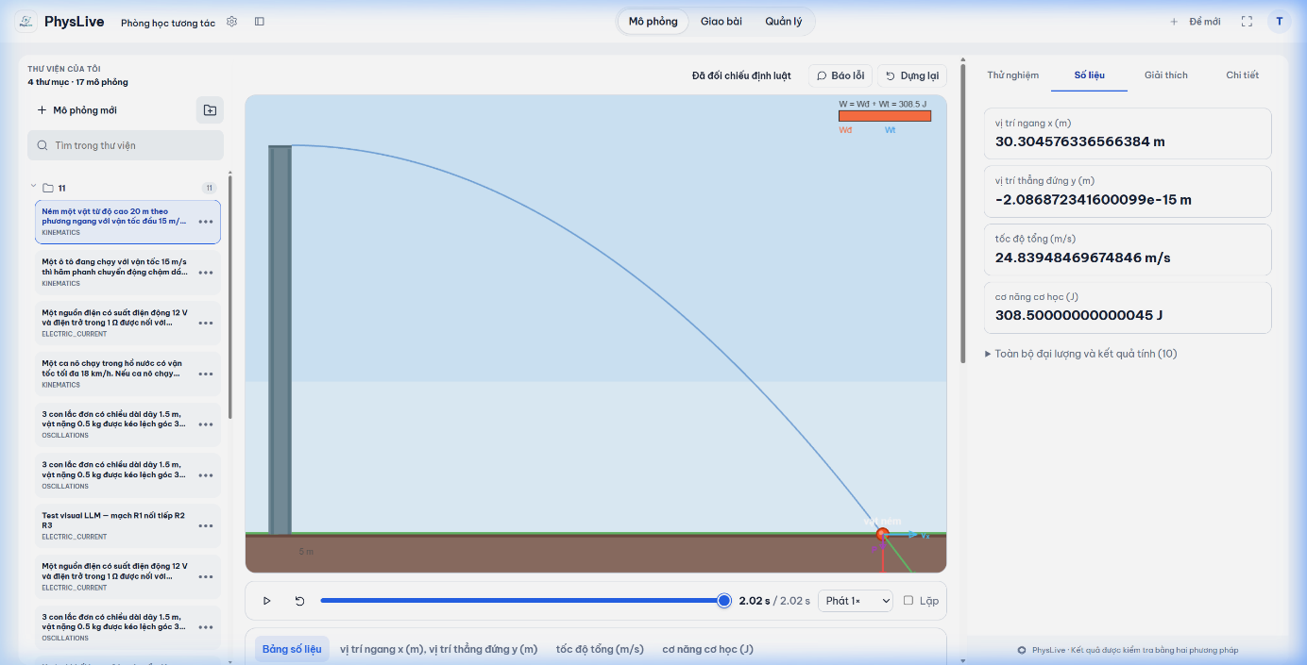
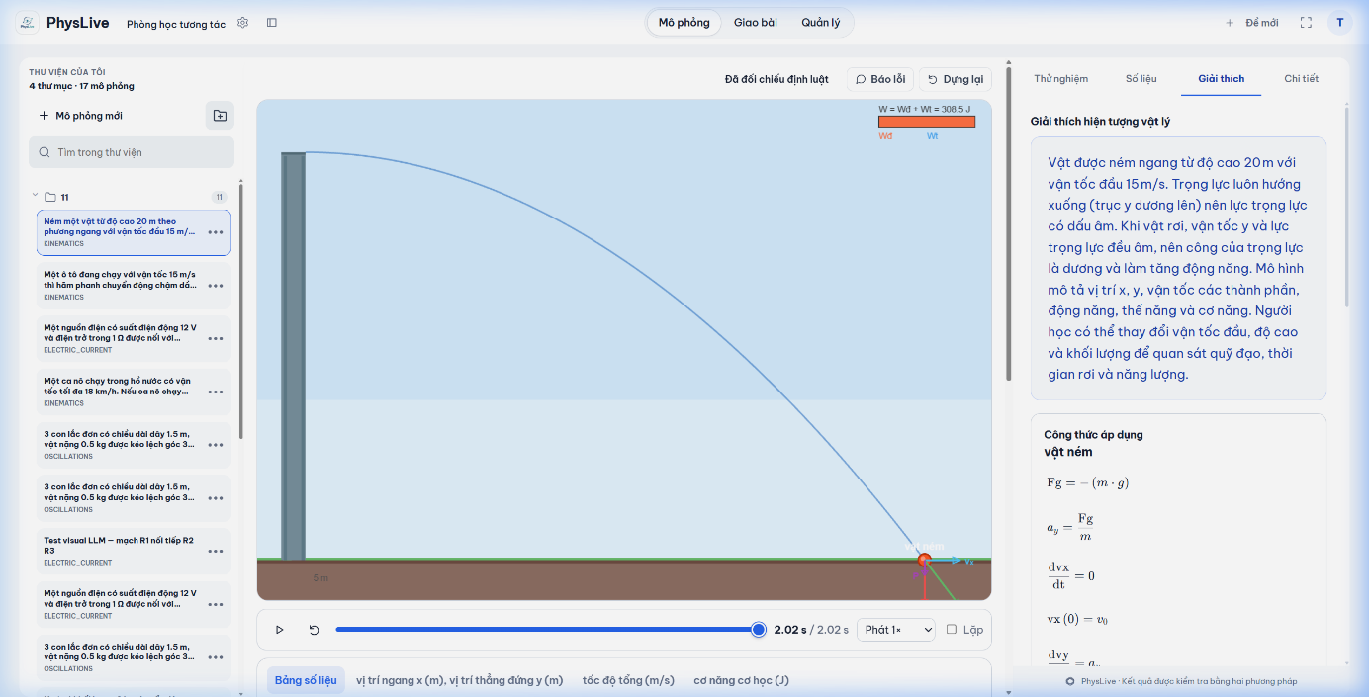
Figure 8. Extracted Physical Quantities & Formula Explanation
Function Details:
- Normal Case:
- System identifies nouns representing physical bodies and extracts their numeric scalar values.
- System automatically converts non-SI units into standard SI units (e.g., converting grams to kg by dividing by 1,000; converting km/h to m/s by dividing by 3.6).
- Constructs the standardized specification JSON payload and stores it into table specifications.
- Abnormal Cases:
- Incompatible dimensions: If problem adds incompatible quantities (e.g., adding 5 kg to 10 meters), system halts and flags: "Dimensional analysis mismatch: Cannot combine mass with distance."
- Contradictory boundary values: If negative mass or negative absolute temperatures are detected, the system displays MSG08: "Invalid physical parameter: Mass must be strictly greater than 0."

3.4 FE-03: Physics Law Verification & Simulation Integrity

3.4.1 Physics Law Verification & Integrity Gate
- Function Trigger: Automatically triggered after successful schema generation before opening the simulation canvas.
- Function Description: Performs verification by executing the physical model through an adaptive 4th-order Runge-Kutta (RK4) numerical integrator, generating a discrete timeline of physical states. At each time step Δt, the verification engine evaluates active quantities against domain invariant laws declared in the Physics Law Catalogue (GDPT 2018). Each run is categorized into one of four verified statuses: VERIFIED (all laws hold true), PARTLY_VERIFIED (primary dynamics hold, minor empirical terms unverified), ILLUSTRATIVE (qualitative demonstration), or FLAGGED (physical invariant violated or numerical instability). If FLAGGED, the model is automatically fed back to the LLM with diagnostic violation metadata for parameter re-synthesis.
- Screen Layout:
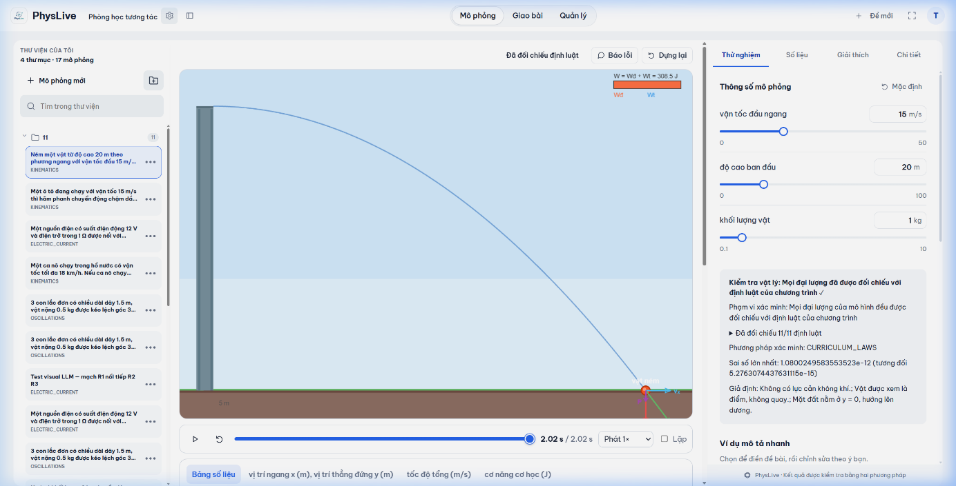
Figure 9. Multi-Tier Physics Law Verification & Self-Repair Workflow
Function Details:
- Normal Case:
- System initializes state vector at time t0.
- Analytical solver computes trajectory over interval T with step size dt = 0.016 s.
- RK4 numerical solver integrates physical trajectories under gravity g = 9.81 m/s² and friction coefficients.
- For invariant conservation (e.g., mechanical energy E): relative invariant error ΔE(t) = |E(t) - E(0)| / E(0). If energy is conserved within numerical integration bounds (ΔE < ε_tolerance), the law check passes.
- If all active law checks pass, the run is tagged status = 'VERIFIED' and validation_passed = true in table simulation_runs, and the teacher is transitioned to /lab.
- Abnormal Cases:
- Physical Invariant Violated (FLAGGED): If a physical law is broken (e.g., kinetic energy artificially increases or dynamic equilibrium fails), system flags status = 'FLAGGED' and validation_passed = false.
- System displays diagnostic notification: "Physics Law Verification Warning: Model violates energy conservation invariant. The simulation has been sent to the AI refinement loop for automatic equation re-adjustment."

3.5 FE-04: Ambiguity Resolution (Human-in-the-Loop)

3.5.1 Interactive Clarification Dialog & Assumption Chips
- Function Trigger: Triggered during NLP problem parsing when incomplete parameters or missing physical assumptions are detected.
- Function Description: When a problem omits crucial parameters (such as surface friction, air resistance, or rope elasticity), the system does not guess arbitrarily. Instead, it pauses extraction and presents the teacher with interactive clarification chips to select standard educational conventions.
- Screen Layout:
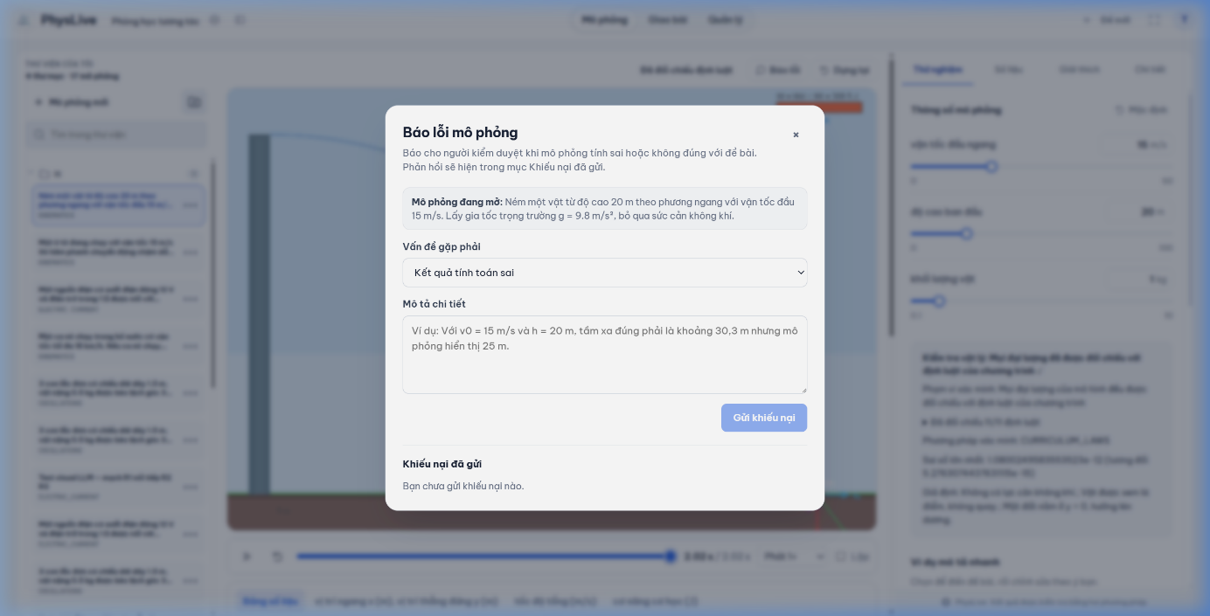
Figure 10. Human-in-the-Loop Clarification & Law Verification Feedback
Function Details:
- Normal Case:
- System identifies missing independent variables required to close the differential equations.
- Displays the Clarification Modal with standard high-school curriculum defaults pre-selected.
- Teacher clicks "Confirm Assumptions & Run". The chosen assumptions are merged into specifications.relations JSON.
- Abnormal Cases:
- Unresolvable Ambiguity: If user enters a custom friction coefficient greater than 1.5 or less than 0.0, system displays: "Friction coefficient must be within the physically realistic interval [0.0, 1.5]."

3.6 FE-05: Interactive Live Classroom Player

3.6.1 2D Physics Canvas & Kinematic Inspector
- Function Trigger: Accessible at /lab upon completing problem verification or opening a simulation from the library.
- Function Description: Renders the interactive 2D simulation canvas powered by HTML5 Canvas with hardware-accelerated WebGL/WebGPU. Teachers and students can interact directly with simulated bodies by pausing, stepping frame-by-frame, dragging objects with mouse interaction, toggling force/velocity vector arrows, and monitoring real-time kinematic graphs (position vs time, velocity vs time, energy conservation).
- Screen Layout :
Figure 11. 2D Kinematic Canvas Player with Vector Displays
Function Details:
- Normal Case:
- System identifies missing independent variables required to close the differential equations.
- Displays the Clarification Modal with standard high-school curriculum defaults pre-selected.
- Teacher clicks "Confirm Assumptions & Run". The chosen assumptions are merged into specifications.relations JSON.
- Abnormal Cases:
- Unresolvable Ambiguity: If user enters a custom friction coefficient greater than 1.5 or less than 0.0, system displays: "Friction coefficient must be within the physically realistic interval [0.0, 1.5]."

3.7 FE-06: Portable Simulation Exporting

3.7.1 Standalone Bundle & Lab Worksheet Generator
- Function Trigger: Staff clicks "Export" on the /lab toolbar.
- Function Description: Empowers educators to export physics simulations into three portable formats: (1) Standalone interactive HTML/JS bundles that run offline without server dependencies, (2) Printable PDF student laboratory worksheets with embedded QR codes, and (3) Shareable cloud deep-links.
- Screen Layout:
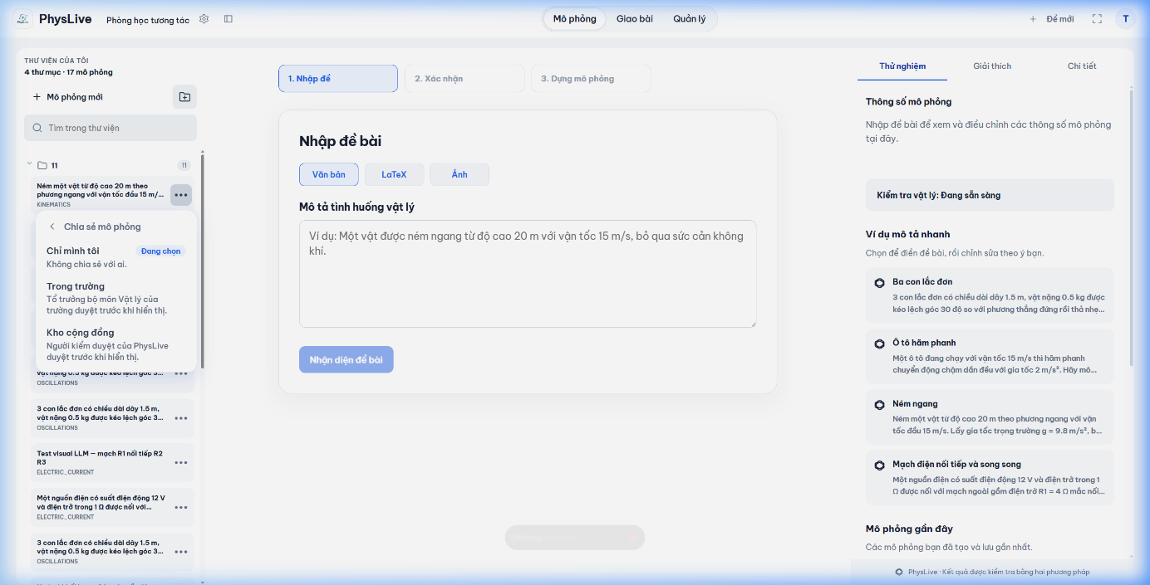
Figure 12. Simulation Export & Multi-tier Sharing Modal
Function Details:
- Normal Case:
- User selects "Export as Offline HTML Bundle".
- System packages the simulation JSON specification, Pixi.js simulation runtime, and vector renderer into a single self-contained HTML file.
- Browser triggers instant download of simulation_bundle.html.
- When opening the file offline, the simulation executes with identical physics behavior.
- Abnormal Cases:
- Restricted Distribution: If the simulation contains copyrighted textbook figures flagged during moderation, exporting as a public link is restricted until reviewer sign-off.

3.8 FE-07: Teacher Library & Assignment Management

3.8.1 Assignment Builder & Class Distribution
- Function Trigger: Staff navigates to /teacher/assignments and clicks "Create New Assignment".
- Function Description: Provides teachers with tools to assemble homework problem sets based on validated simulations. Teachers configure due dates, maximum scores, submission instructions, and anti-cheat parameter variation ranges before assigning to specific school classes.
- Screen Layout:
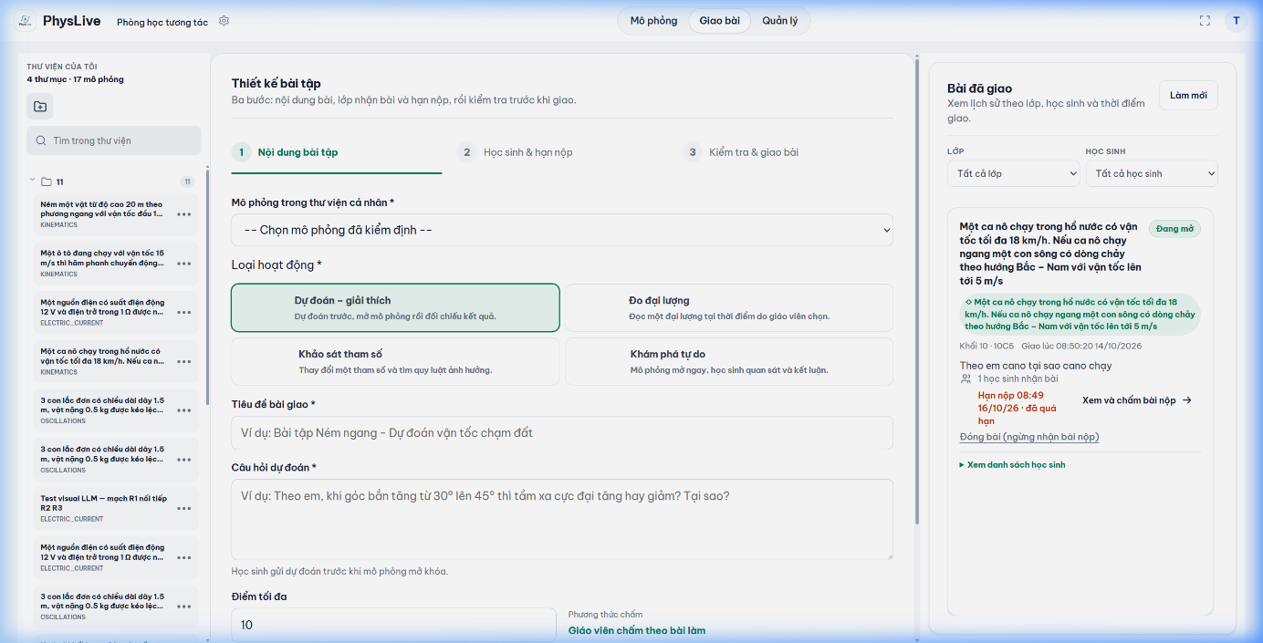
Figure 13. 3-Step Assignment Creator with POE Activities
Function Details:
- Normal Case:
- Teacher inputs title, selects assigned class, sets deadline, and configures parameter bounds.
- Teacher checks "Enable Unique Student Parameter Seed".
- Teacher clicks "Publish". The record is stored in assignments with status = 'PUBLISHED'.
- All students enrolled in the class immediately receive a notification on their /student/assignments dashboard.
- Abnormal Cases:
- Invalid Deadline: If teacher sets due date in the past, system blocks submission with MSG08: "Due date must be set to a future timestamp."

3.9 FE-08: Student Prediction & Replay Sandbox

3.9.1 POE (Predict-Observe-Explain) Assessment Player
- Function Trigger: Student clicks "Start Task" on /student/assignments/:id.
- Function Description: Implements a strict three-stage pedagogical workflow: Predict, Observe, and Explain. The student is presented with problem parameters uniquely generated for them via the seeded PRNG algorithm. The student must submit their theoretical numerical prediction before the interactive simulation canvas is unlocked.
- Screen Layout:
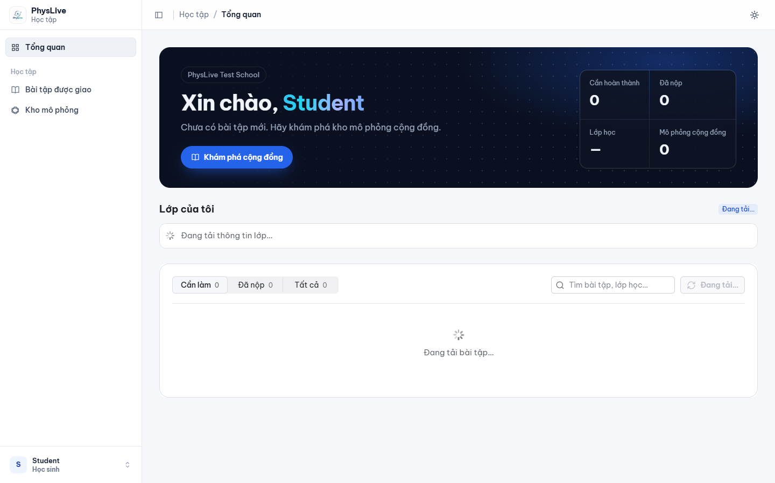
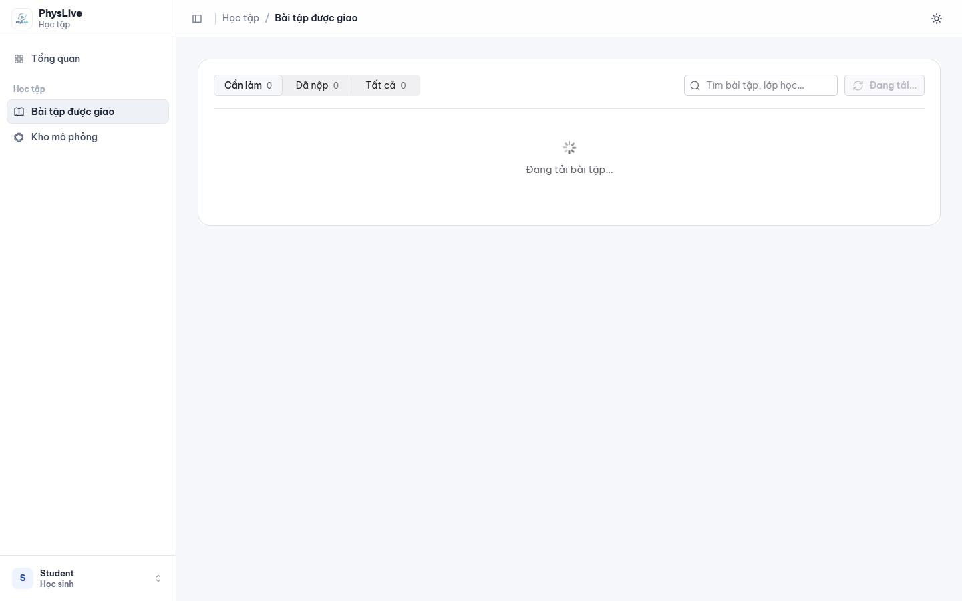
Figure 14. Student Learning Dashboard & Assignment Portal

Function Details:
- Normal Case:
- System computes assigned parameters using student ID and assignment seed.
- Student calculates answers and submits numeric predictions.
- Predictions are locked into assignment_submissions.predictions.
- Stage 2 (Canvas Simulation) unlocks, allowing student to run the 2D experiment and compare empirical results with their theoretical prediction.
- Student enters written explanation and clicks "Final Submit".
- System auto-calculates score based on a ±5.0% error margin against ground truth and records the grade.
- Abnormal Cases:
- Attempting Late Submission: If current time > due_at and late submission is not enabled, the player disables input controls with MSG11: "Assignment submission deadline has passed."

3.10 FE-09: Content Curation & Schema Workspace

3.10.1 Peer-Review Moderation & Benchmark Schema Auditor
- Function Trigger: Reviewer logs into /reviewer/moderation.
- Function Description: Dedicated administrative portal for designated subject experts to inspect community simulation submissions. Reviewers verify physical law accuracy, audit formula descriptions, check visual pedagogical clarity, and either approve items for publication on the National Public Library or reject them with detailed feedback.
- Screen Layout:
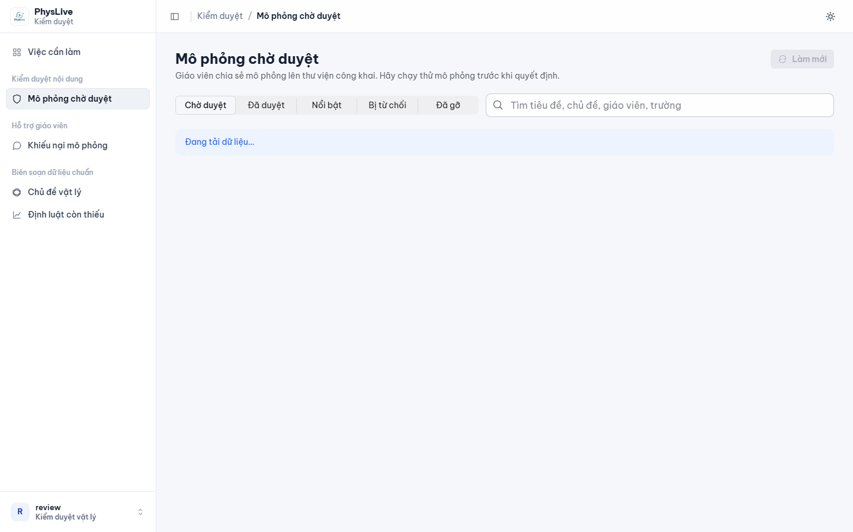
Figure 15. Reviewer Moderation Queue for Shared Simulations
Function Details:
- Normal Case:
- Reviewer selects a pending simulation from the queue (status = 'PENDING_REVIEW').
- Reviewer executes Physics Law Invariant Gate diagnostic replay and inspects underlying schema parameters.
- Reviewer enters comments and clicks "Approve for Public Library".
- Item status is updated to PUBLIC in table library_items, making it instantly discoverable at /community.
- Abnormal Cases:
- Rejection with Required Revision: If physical inaccuracies or incorrect formulas are discovered, reviewer selects "Reject with Feedback" and enters revision requirements. Status transitions to REJECTED, notifying the author teacher to revise and re-submit.

3.11 FE-10: System Administration (Users & Topics)

3.11.1 School Quota Administration & 3-Tier Curriculum Taxonomy
- Function Trigger: Manager navigates to /manager/schools or /manager/curriculum.
- Function Description: Provides platform administrators and operations managers with comprehensive tools to manage multi-tenant institutions, configure annual B2B subscription plans, audit token ledger balances, resolve suspended account appeals, and maintain the standardized Vietnamese secondary physics curriculum hierarchy.
- Screen Layout:
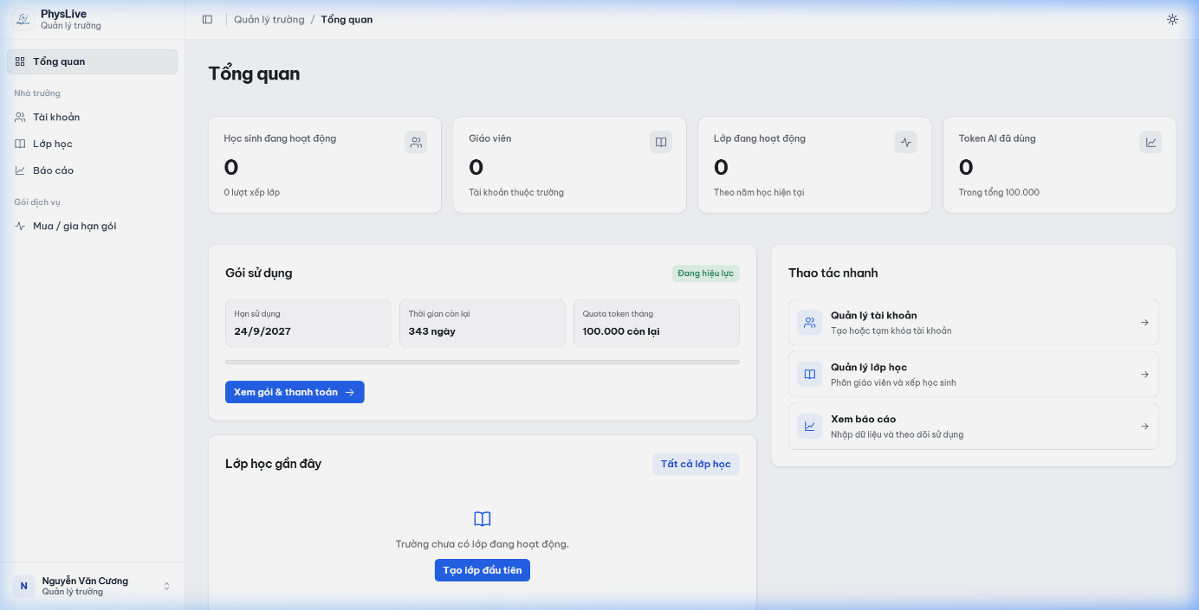
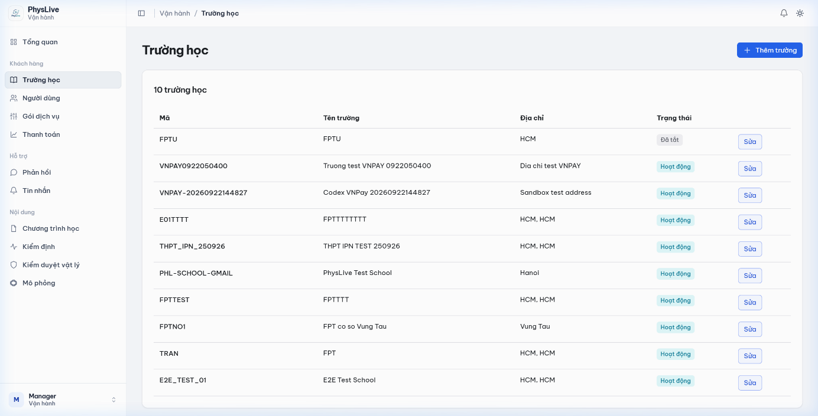
Figure 16. School Tenant Console & Platform Manager View
Function Details:
- Normal Case:
- Manager reviews institutional subscription registrations and verifies bank transfer documentation.
- Manager updates school status to ACTIVE and allocates monthly token quota (e.g., 50,000 tokens).
- In /manager/curriculum, manager creates and arranges topics, content modules, grade levels, and lessons with standardized hierarchical codes (K01, K01-10, K01-10-01).
- In /manager/users, manager reviews appeals submitted by users with SUSPENDED_READ_ONLY status and decides on reinstatement.
- Abnormal Cases:
- License Expiration: When a school's license end date is reached, scheduled worker NS-06 automatically flags the school and all affiliated teacher accounts as read-only, preventing new simulation creation while preserving existing educational records.

4. Non-Functional Requirements

4.1 External Interfaces

4.1.1 User Interfaces
- Frontend Architecture & Visual Consistency: The user interface is implemented as a modern Single Page Application (SPA) using React 19, Vite 7, Radix UI Themes, and TailwindCSS v4. It enforces an accessible, high-contrast visual design system featuring unified surface elevations, border radii (12px to 18px), and modern typography (Inter and Outfit web fonts).
- Responsive Breakpoints: The layout dynamically adapts across 4 standardized screen tiers:
  - Desktop (≥ 1280px): 3-pane interactive studio layout (Problem Ingestion, Kinematic Canvas, Simulation Inspector).
  - Laptop (1024px – 1279px): Collapsible sidebar and flexible 2-column workspace.
  - Tablet (768px – 1023px): Stacked vertical layout with swipeable tabs for Inspector and Canvas.
  - Mobile (≤ 767px): Simplified responsive view optimized for student assignment review and POE prediction submissions.
- Simulation Canvas Rendering: The 2D physics simulation viewport renders via HTML5 Canvas accelerated by Pixi.js with hardware-accelerated WebGL/WebGPU, maintaining a consistent 60 FPS (frames per second) refresh rate. Viewports automatically adjust for device pixel ratio (window.devicePixelRatio) to guarantee sharp rendering on high-DPI and Retina displays.
- Theme Support: Supports dark and light color modes with WCAG-compliant contrast ratios (≥ 4.5:1 for body copy, ≥ 3:1 for interactive icons and controls).

4.1.2 Hardware Interfaces
- Client Device Specifications:
  - Minimum Hardware: Dual-core x86/ARM CPU @ 2.0 GHz, 4 GB RAM, WebGL 2.0 compatible GPU, minimum screen resolution 1280 × 720 pixels.
  - Recommended Hardware: Quad-core CPU @ 2.5 GHz or higher, 8 GB RAM, dedicated or modern integrated GPU (Intel Iris Xe, Apple Silicon M-series, AMD Radeon, NVIDIA GTX), Full HD display (1920 × 1080 pixels).
- Server Infrastructure:
  - Application Pods: Cloud container instances running Linux x86_64, minimum 2 vCPU and 4 GB RAM per container instance.
  - Database Cluster: Managed PostgreSQL database instances with dedicated IPv4 transaction poolers capable of supporting at least 100 concurrent client database connections.

4.1.3 Software Interfaces
- Cloud Multi-Modal AI & LLM Providers:
  - Communicates with OpenRouter / OpenAI API endpoints via HTTPS REST calls to perform OCR image-to-text extraction and semantic problem decomposition.
  - Enforces structured JSON output parsing against domain-specific physics schemas.
- Backend Application Server:
  - Implemented with Spring Boot 3.3.4 running on Java 21 LTS.
  - Leverages Spring Security for JWT authentication and RBAC authorization filters.
  - Utilizes Hibernate ORM 6.5.3 and PostgreSQL JDBC driver (v42.7.4) for relational persistence.
- Database & Persistence Tier:
  - Hosted on Supabase Cloud PostgreSQL 15.
  - Database schema evolutions are managed strictly through Flyway automated database migrations (Migrations V1 through V50).
- Export & Client Runtimes:
  - Client canvas rendering engine powered by Pixi.js v8 and Pixi.js v8.21.0.
  - Standalone simulation bundles export into self-contained HTML/JS bundles executing without active server connections.

4.1.4 Communications Interfaces
- Network Protocols:
  - HTTPS (TLS 1.3): All network exchanges between client browsers and backend servers are strictly encrypted over HTTPS. Unencrypted HTTP requests are automatically upgraded to HTTPS.
  - Server-Sent Events (SSE) / WebSockets: Used for real-time status streaming during long-running LLM multi-modal problem understanding requests.
- Data Exchange Format:
  - Standardized JSON (JavaScript Object Notation, RFC 8259) payload format for all request bodies and response entities.
  - Standard HTTP response codes are consistently mapped: 200 OK, 201 Created, 400 Bad Request, 401 Unauthorized, 403 Forbidden (with custom localized error body), 404 Not Found, 422 Unprocessable Entity, and 500 Internal Server Error.

4.2 Quality Attributes

4.2.1 Usability
- Operational Efficiency: A physics teacher can complete the creation of a new simulation from raw text or OCR upload in less than 3 minutes, including variable verification and assignment packaging.
- Learning Curve: First-time students can log in, view assigned homework, submit their initial POE prediction, and interact with the 2D canvas simulation within 5 minutes without external instructional manuals.
- Interactive Control Feedback: Scrubbing time sliders, dragging parameter knobs, and toggling vector overlays trigger canvas updates within 16 ms (sub-frame latency), providing tactile responsiveness.
- Input Error Recovery: Input fields provide immediate inline validation. When physics quantities or units are missing, the system highlights the missing variable chips (FE-04) and allows single-click default resolution.
- Accessibility (WCAG 2.1 AA): All text elements maintain a contrast ratio of at least 4.5:1 against their backgrounds. All interactive buttons provide visible keyboard focus rings, and core simulation controls support standard keyboard shortcuts (Space = Play/Pause, R = Reset, Left/Right Arrow = Step 0.05 s).
- Localization: 100% of user interface labels, physics concepts, error alerts, and curriculum taxonomy are presented in standardized Vietnamese educational terminology conforming to the GDPT 2018 national curriculum.

4.2.2 Reliability & Availability
- System Availability: The platform guarantees an uptime of ≥ 99.5% during core school operating hours (07:00 to 22:00 GMT+7, Monday through Saturday), corresponding to less than 3.6 hours of unplanned downtime per month.
- Mean Time Between Failures (MTBF): System architecture is engineered for an MTBF of ≥ 720 consecutive operating hours (30 calendar days).
- Mean Time To Repair (MTTR): In the event of application server container failure, automated orchestration restarts and restores service within an MTTR of ≤ 10 minutes.
- Physics Law Integrity Gate: Simulations are certified as VERIFIED only when RK4 numerical integration calculations strictly conform to all active domain physical laws (conservation of energy, momentum, Newton's laws) in the curriculum catalogue, ensuring complete physical fidelity.
- Defect Rate & Quality Gates: At release gate, the system maintains 0 Critical (Severity 1) defects, ≤ 2 Major (Severity 2) defects, and ≤ 5 Minor (Severity 3) defects per 10,000 lines of executable code.
- Fault Tolerance & Graceful Degradation: If cloud LLM services experience temporary latency spikes (> 15 seconds), the frontend gracefully switches to a retry countdown with manual parameter entry, preventing unhandled UI crashes.

4.2.3 Performance & Scalability
- API Response Latency:
  - Standard CRUD operations (class management, assignment listing, profile updates): P95 latency ≤ 300 ms.
  - Complex analytical solver calculations: P95 latency ≤ 500 ms.
  - LLM multimodal ingestion and problem decomposition: P90 latency ≤ 3.5 seconds.
- Simulation Frame Rate: HTML5 Canvas simulation rendering sustains a steady 60 FPS (≥ 58 FPS average) with physics time-step Δt = 0.016 s under standard classroom simulation loads (up to 5 concurrent bodies, vectors, and energy bar charts).
- Concurrent Load Capacity:
  - Supports at least 200 concurrent active students per subscribing school tenant.
  - Capable of handling at least 50 simultaneous active simulation execution sessions per school without client-side lag or server-side CPU throttling.
- Client Resource Footprint: Total web browser heap memory allocation remains strictly below 350 MB during continuous 60-minute simulation sessions, with zero memory leaks across consecutive simulation resets.
- Database Query Efficiency: All transactional queries utilize indexed foreign keys and composite indexes, ensuring that 99% of relational database queries execute in under 50 ms.

4.2.4 Security & Data Protection
- Role-Based Access Control (RBAC): Strict enforcement of the 7 system roles (GUEST, STUDENT, STAFF, SCHOOL, REVIEWER, MANAGER, ADMIN) across all API routes and UI views. Unauthorized API access requests are rejected immediately with HTTP 401 Unauthorized or HTTP 403 Forbidden.
- Stateless Authentication: User authentication utilizes cryptographic JSON Web Tokens (JWT) signed with HMAC-SHA256, carrying an expiration lifespan of 60 minutes. Refresh tokens are securely stored in HTTP-only, SameSite cookies.
- Password Security: User passwords must meet a minimum complexity of 8 characters and are hashed using the BCrypt algorithm with a salt work factor of 10. Plaintext passwords are never logged or stored.
- Multi-Tenant Data Isolation (Row-Level Security): All database entities (classes, teachers, students, assignments, submissions) are partition-bound by school_id. PostgreSQL Row-Level Security (RLS) policies prevent users from School A from querying, reading, or modifying data belonging to School B.
- Anti-Cheat Deterministic PRNG Seeding: Homework assignment variable values are pseudo-randomly generated using a seeded PRNG formula: seed = hash(assignment_id + student_id) This guarantees that every student receives unique numeric values (preventing direct copying of answers), while teacher grading engines deterministically reproduce the identical values for automated verification.
- 3-Tier Account Suspension Governance: Suspended user accounts (SUSPENDED_READ_ONLY) retain read-only permission to inspect their past work and submit formal appeal requests via /api/appeals. All data mutation actions (POST, PUT, DELETE) are strictly denied at the security filter layer with HTTP 403 Forbidden and explanatory Vietnamese feedback.

4.2.5 Portability & Compatibility
- Cross-Browser Verification: The web application is verified to operate without functional or visual discrepancies on:
  - Google Chrome (Version 110 and newer)
  - Microsoft Edge (Version 110 and newer)
  - Mozilla Firefox (Version 115 and newer)
  - Apple Safari (Version 16 and newer)
- Cross-Platform Compatibility: The platform functions seamlessly across operating systems including Windows 10/11, macOS 12+, Ubuntu Linux 20.04+, iPadOS 16+, and Android 12+ on tablet-class touch devices.
- Standalone Simulation Portability: Exported simulation packages (.html, .json) include embedded Pixi.js v8 runtimes and model schemas, enabling them to execute completely offline in any standard web browser without server communication.

4.2.6 Maintainability & Supportability
- Tiered Architectural Modularity: Clean separation of concerns between client presentation components, domain services, numerical solvers, and database access objects.
- Database Migration Governance: All database changes are tracked version-by-version using Flyway migration scripts, guaranteeing reproducible test environments and frictionless deployment.
- Automated Test Coverage: Codebase maintains an automated test coverage of ≥ 80% across business service methods, physics calculation algorithms, and security permission evaluators.
- Comprehensive System Logging: Utilizes SLF4J with Logback to record timestamped, structured JSON execution logs. Security-critical events (login failures, quota adjustments, role updates, account suspensions) are captured in audit tables with user ID and client IP tracking.

5. Requirement Appendix

5.1 Business Rules
The following table summarizes the foundational business rules governing operational logic, physical accuracy, and institutional compliance throughout the PhysLive platform:

Rule ID | Rule Category | Summary Definition | Enforcement Mechanism
BR-01 | Physical Fidelity | Physics Law Invariant Compliance: Simulation timelines must strictly satisfy domain conservation and dynamical laws in the GDPT 2018 Law Catalogue. | Automated validation gate prior to saving or publishing simulation models.
BR-02 | Academic Integrity | Anti-Cheat Seeded Randomization: Student assignment variables are generated via deterministic PRNG seeded with hash(assignment_id + student_id). | Assignment engine generates unique numeric values per student while maintaining deterministic grading.
BR-03 | Commercial Licensing | B2B School Token Pool: Institutions subscribe to annual pooled AI token quotas. Quotas reset annually without rollover; zero balance switches AI problem generation to queued mode. | Spring Boot billing interceptor evaluates remaining institutional quota on every LLM API call.
BR-04 | User Governance | 3-Tier Suspension Lifecycle: Accounts transition through ACTIVE → WARNED → SUSPENDED_READ_ONLY. Suspended accounts maintain read-only access and appeal privileges. | Spring Security filter blocks all mutation requests with HTTP 403 while permitting GET access to appeal endpoints.
BR-05 | Pedagogical Flow | Mandatory POE Sequence: Students must submit initial predictions and scientific rationales before the interactive canvas simulation controls unlock. | Frontend state machine locks Canvas play controls until valid prediction is submitted to the backend.
BR-06 | Curriculum Standard | 3-Tier Curriculum Taxonomy: All simulations map to standardized hierarchical codes: K (Root) → K01 (Discipline) → K01-10 (Grade) → K01-10-01 (Lesson). | Automatic identifier generator validates code syntax against the official GDPT 2018 curriculum registry.
BR-07 | Content Moderation | Two-Tier Community Publishing: Sharing to the community library requires Teacher submission → School HOD endorsement → PhysLive Reviewer audit within 48 hours. | Workflow state transition engine manages state progression from DRAFT to PENDING_REVIEW to PUBLIC.
BR-08 | Data Portability | Standalone Export Immutability: Exported offline bundles (.html/.json) contain self-contained runtime scripts and fixed parameters, preventing tampering. | Checksum hash verified upon bundle loading; local runtime operates strictly offline.

5.2 Common Requirements
- Global Navigation & Identity Header:
  - Every authenticated screen displays the unified PhysLive header containing the system brand logo, active workspace switcher, institutional school identifier, notification bell, and user avatar dropdown.
  - User profile dropdown exposes direct actions: Profile Settings, Change Password, Language Preferences, and Secure Sign Out.
- Contextual Breadcrumb Navigation:
  - All nested hierarchical views (e.g., Curriculum Topics → Grade Levels → Lesson Simulations) maintain breadcrumb trails enabling single-click navigation back to any parent container.
- Standardized Notification & Toast System:
  - System feedback utilizes non-intrusive toast alerts anchored at the top-right viewport:
    - Success (Green): Operations completed successfully (auto-dismiss after 3.5 seconds).
    - Warning (Amber): Non-blocking discrepancies or approaching quota limits (auto-dismiss after 5 seconds).
    - Error (Red): Action failures or validation errors (persistent until explicitly dismissed by user).
    - Info (Blue): Asynchronous background job completion notices.
- Optimistic UI Updates & Loading Skeletons:
  - Data mutations (e.g., renaming a simulation, reordering assignment questions) update the UI optimistically while executing background API requests.
  - Data loading states utilize pulse-animated skeleton placeholders rather than intrusive blocking screen overlays.
- Modal Dialog Standard Behaviors:
  - All dialogs feature semi-transparent background scrims (backdrop-filter: blur(3px)).
  - Dialogs close smoothly on Esc keypress or external scrim click (unless designated as a blocking confirmation flow).

5.3 Application Messages List
Code | Type | Context / Trigger Condition | UI Presentation | Message Content (English / Vietnamese)
MSG-01 | Error | Authentication failed due to invalid credentials | Inline Alert | EN: Invalid email address or password. Please try again.  VI: Email hoặc mật khẩu không chính xác. Vui lòng kiểm tra lại.
MSG-02 | Error | Required form field is submitted empty | Inline Field Error | EN: This field is required and cannot be left blank.  VI: Trường này là bắt buộc, vui lòng không để trống.
MSG-03 | Error | Input numeric parameter exceeds physical domain boundary | Inline Field Error | EN: Value must be between {min} and {max} {unit}.  VI: Giá trị phải nằm trong khoảng từ {min} đến {max} {unit}.
MSG-04 | Warning | Problem statement lacks necessary physical variables | Clarification Chip | EN: Ambiguous condition detected: Missing initial velocity or mass. Please clarify.  VI: Phát hiện dữ kiện chưa rõ: Thiếu vận tốc đầu hoặc khối lượng. Vui lòng làm rõ.
MSG-05 | Warning | Physics Law Verification Warning: Simulation violates domain physical invariants (e.g., Energy Conservation or Newton's Laws). Returned for automatic AI refinement. | Modal Alert | EN: Simulation verification notice: Model violates physical invariant '{law}'. It has been routed to the AI self-repair loop for parameter refinement.  VI: Cảnh báo kiểm định vật lý: Mô hình vi phạm định luật '{law}'. Hệ thống đã tự động chuyển sang vòng lặp sửa lỗi AI để hiệu chỉnh tham số.
MSG-06 | Success | Physics simulation created and validated successfully | Toast Notification | EN: Simulation generated and validated successfully.  VI: Mô phỏng vật lý đã được tạo và kiểm định thành công.
MSG-07 | Success | Simulation state saved to teacher personal library | Toast Notification | EN: Simulation saved to library folder "{folder_name}".  VI: Đã lưu mô phỏng vào thư mục "{folder_name}".
MSG-08 | Warning | Institutional AI token quota balance is nearly depleted (< 5%) | Top Banner | EN: School AI token quota is below 5%. Please contact your administrator to renew.  VI: Dung lượng AI Token của trường còn dưới 5%. Vui lòng liên hệ quản trị viên để gia hạn.
MSG-09 | Error | Institutional AI token quota is completely exhausted (0 balance) | Modal Alert | EN: AI generation quota exhausted. Request has been queued or requires token upgrade.  VI: Hết hạn mức AI Token. Yêu cầu đã chuyển vào hàng đợi hoặc cần nâng cấp gói.
MSG-10 | Warning | Student attempts to run simulation before submitting POE prediction | Toast Warning | EN: Please submit your initial prediction before starting the simulation playback.  VI: Vui lòng gửi dự đoán khoa học của bạn trước khi chạy mô phỏng.
MSG-11 | Success | Student POE prediction and explanation submitted | Toast Notification | EN: Prediction recorded successfully. You may now run the simulation.  VI: Đã ghi nhận dự đoán thành công. Bây giờ bạn có thể chạy mô phỏng.
MSG-12 | Success | Assignment published and distributed to class roster | Toast Notification | EN: Assignment "{title}" published to {count} students in Class {class_name}.  VI: Đã giao bài tập "{title}" cho {count} học sinh lớp {class_name}.
MSG-13 | Info | OCR image upload processing in background | Progress Banner | EN: AI is analyzing the problem image. Please wait 10 to 30 seconds...  VI: AI đang đọc ảnh đề bài và trích xuất dữ kiện. Vui lòng chờ 10 đến 30 giây...
MSG-14 | Error | OCR image resolution is too blurry or unreadable | Alert Card | EN: Image text could not be recognized. Please upload a clearer image or enter text manually.  VI: Không thể nhận diện chữ từ ảnh. Vui lòng tải ảnh rõ hơn hoặc nhập đề bằng văn bản.
MSG-15 | Success | Shared simulation submitted for moderation review | Toast Notification | EN: Simulation submitted to school and community moderation queue.  VI: Đã gửi mô phỏng vào hàng đợi thẩm định của trường và cộng đồng.
MSG-16 | Success | Reviewer approved simulation for public community library | Toast Notification | EN: Simulation "{title}" approved and published to the Community Library.  VI: Mô phỏng "{title}" đã được duyệt và phát hành lên Kho thư viện cộng đồng.
MSG-17 | Warning | Reviewer rejected simulation with feedback notes | Toast Warning | EN: Simulation returned for revision: {reason}.  VI: Mô phỏng được yêu cầu chỉnh sửa lại: {reason}.
MSG-18 | Error | Account suspended; write operations blocked | Floating Banner | EN: Your account is currently in Read-Only suspension. Submit an appeal to request review.  VI: Tài khoản đang ở chế độ Tạm khóa (Chỉ đọc). Bạn có thể gửi khiếu nại để được xem xét.
MSG-19 | Success | User account appeal submitted successfully | Modal Notification | EN: Your appeal has been submitted to platform administrators for evaluation.  VI: Khiếu nại của bạn đã được gửi tới ban quản trị để giải quyết.
MSG-20 | Success | Standalone offline simulation bundle exported | Toast Notification | EN: Standalone simulation package exported successfully ({format}).  VI: Đã xuất gói mô phỏng tương tác ngoại tuyến thành công ({format}).

5.4 Other Requirements, Acronyms & Glossary

5.4.1 Acronyms & Terminology Glossary
- POE (Predict - Observe - Explain): An evidence-based educational pedagogy where students predict physical outcomes before witnessing the phenomenon, observe the dynamic simulation, and explain discrepancies between their hypothesis and scientific reality.
- RK4 (Runge-Kutta 4th Order): A high-precision numerical integration algorithm used by the PhysLive analytical solver to solve ordinary differential equations (ODEs) governing non-linear kinematic and oscillatory motions.
- Pixi.js v8: A robust 2D rigid-body JavaScript physics engine powering real-time kinetic collision detection, friction, and restitution on the client canvas.
- Pixi.js: A high-performance 2D WebGL rendering library utilized for drawing scalable visual scenes, force vectors, field lines, and particle trajectories at 60 FPS.
- SI Units (Système International): The standard metric physical units enforced across all inputs and calculations (meter m, kilogram kg, second s, Ampere A, Kelvin K, Joule J, Newton N, Watt W).
- PRNG (Pseudorandom Number Generator): An algorithm for generating sequences of numbers whose properties approximate the properties of random numbers, seeded deterministically per student ID.
- RLS (Row-Level Security): A PostgreSQL security feature controlling which database rows are returned or modifiable based on user role and tenant context.
- RBAC (Role-Based Access Control): An access control paradigm restricting system functionality based on assigned user roles.
- P95 / P90 Latency: 95th / 90th percentile latency, representing the maximum response time experienced by 95% or 90% of requests.
- B2B SaaS: Business-to-Business Software-as-a-Service model providing subscription-based educational software to institutions.

